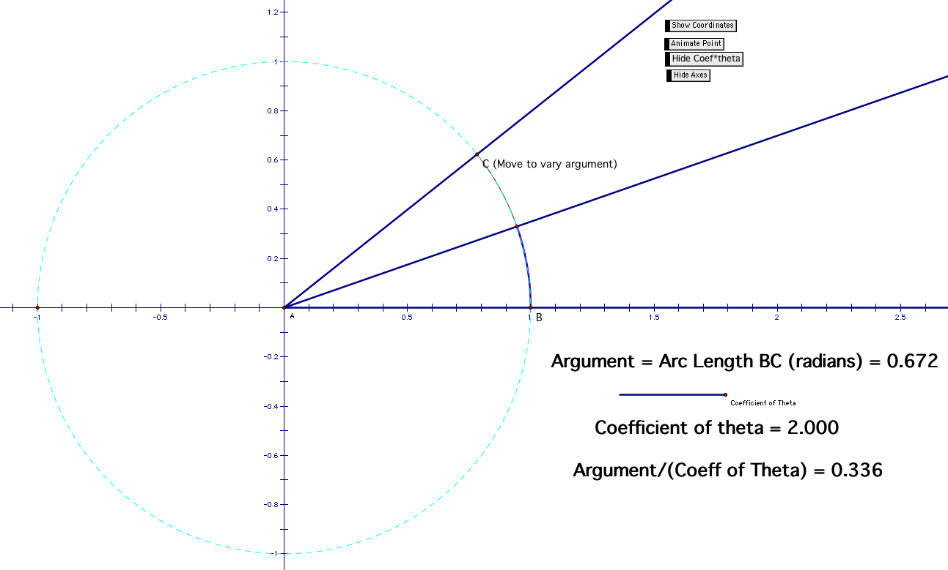
Instructor Comments: This applet is designed to help students understand how the period changes as the argument of the sine function is changed. By dragging point the bar under the Argument, you can vary the size of the coefficient in front of theta (from the function y = sin(Coeff•θ)). Then students can make conjectures about what the resulting period will be. After that, drag point C around the circle for one revolution and watching the other ray will determine what the ‘new’ period is.

