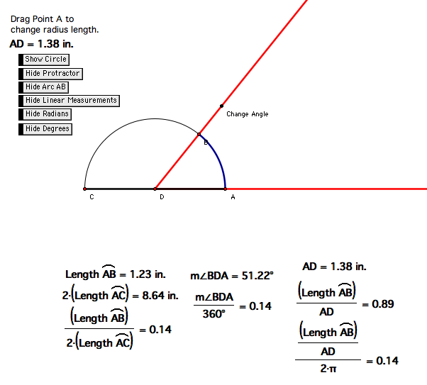
Instructor Comments: By moving point ‘A’ on the applet or the point labeled “Change Angle,” the radius of the protractor or the openness of the angle can be varied, respectively. This will allow an investigation into directional changes of angle measure and how these changes are related to the relationship of arc-length as a fraction of a circle’s circumference. The measurements given in radians will not be visible during the first use of the applet, as the radian has yet to be introduced. During the use of the applet, the students will be asked to identify each measurement and its relationship to the applet (e.g., “Where does this measurement refer to?”). With each measurement identified on the applet, the applet will then be used to generate a discussion of how each measurement changes as i) the openness of the angle is increased or decreased and as ii) the radius of the protractor is increased or decreased. For example, the students are hoped to identify that as the openness of an angle increases the arc-length subtended increases, the fraction of the circumference cutoff by the angle increases, and the proportion of the angle measure in degrees to 360 degrees remains equal to the fraction of the linear measurement of the arc-length cutoff to the total circumference of the circle formed by the protractor.

