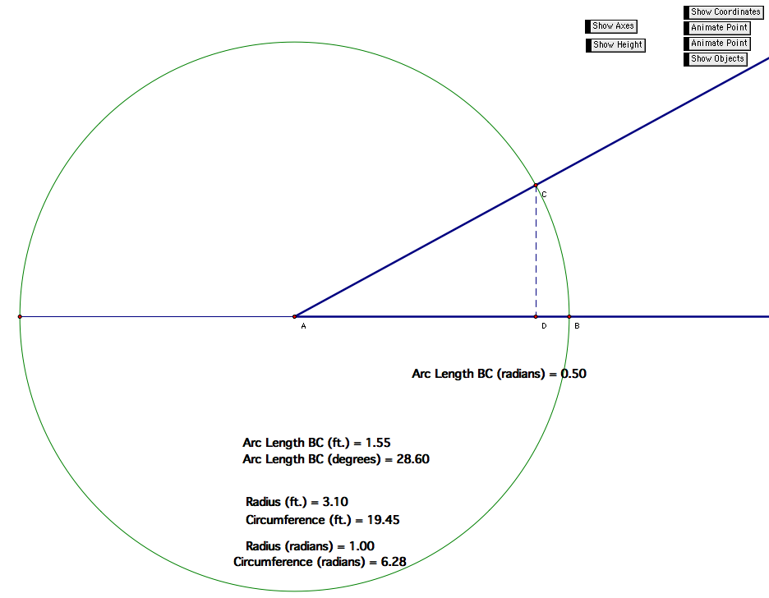

Instructor Comments: Use this applet to discuss the domain and range of the inverse trig functions. Ask the students over what interval of input to sine and cosine do you vary over all possible outputs. Because these outputs are your inputs to the inverse functions, the inverse functions will only give you the corresponding outputs. Using the applet, ask the students how they can determine the arc-lengths from the standard position for the other coordinates you may like.

