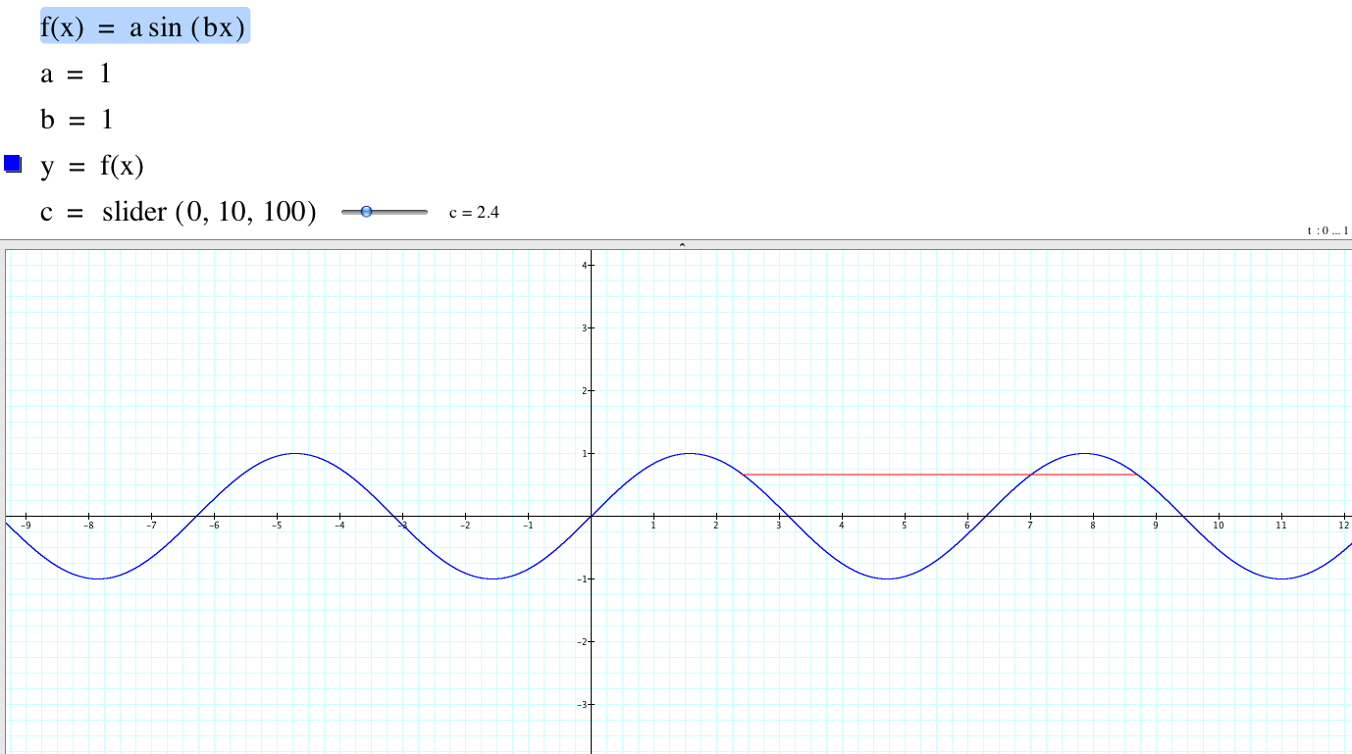

Instructors comments: This applet is intended to help foster students’ understanding of period by looking at the relationship between corresponding points at the beginning and ending of 1 period. The values of a and b can be changed to generate other graphs. Use the slider on c to move the red ‘period’ bar around.

